Batch: A2 Roll No.: 16010122034

Experiment No. 8

Grade: AA / AB / BB / BC / CC / CD /DD

Signature of the Staff In-charge with date

Title: Implementation of BST & Binary tree traversal techniques.

Objective: To Understand and Implement Binary Search Tree, Preorder, Postorder and Inorder Traversal Techniques.

Expected Outcome of Experiment:

CO | Outcome
1 | Explain the different data structures used in problem solving

Books/ Journals/ Websites referred:
- Fundamentals Of Data Structures In C – Ellis Horowitz, Satraj Sahni, Susan Anderson-Fred
- An Introduction to data structures with applications – Jean Paul Tremblay,
Paul G. Sorenson
- Data Structures A Pseudo Approach with C – Richard F. Gilberg & Behrouz A. Forouzan
- https://www.geeksforgeeks.org/binary-tree-data-structure/
- https://www.thecrazyprogrammer.com/2015/03/c-program-for-binary-search-tree-insertion.html

Abstract:
A tree is a non- linear data structure used to represent hierarchical relationship existing among several data items. It is a finite set of one or more data items such that, there is a special data item called the root of the tree. Its remaining data items are partitioned into number of mutually exclusive subsets, each of which is itself a tree, and they are called subtrees.

A binary tree is a finite set of nodes. It is either empty or It consists a node called root with two disjoint binary trees-Left subtree, Right subtree. The Maximum degree of any node is 2
A Binary Search Tree is a node-based binary tree data structure in which the left subtree of a node contains only nodes with keys lesser than the node’s key. The right subtree of a node contains only nodes with keys greater than the node’s key. The left and right subtree each must also be a binary search tree.
Related Theory: -
Preorder Traversal of BST
In a preorder traversal of a binary search tree (BST), the nodes are visited in a top-down manner. The algorithm starts at the root node, visits it, then recursively traverses the left and right subtrees. Preorder traversal is often used to create a copy of the tree or to serialize the tree for storage or transmission.

Postorder Traversal of BST
In a postorder traversal of a binary search tree (BST), the nodes are visited in a bottom-up manner. The algorithm first traverses the left and right subtrees and then visits the current node. Postorder traversal is useful for tasks that require visiting the child nodes before the parent node, such as deleting a tree or certain tree transformations.

Inorder Traversal of BST
In an inorder traversal of a binary search tree (BST), the nodes are visited in ascending order of their values. The basic idea is to first traverse the left subtree, then visit the current node, and finally traverse the right subtree. This results in a sorted list of elements when applied to a BST, as the left subtree contains smaller values, the current node is the middle value, and the right subtree contains larger values.

Diagram
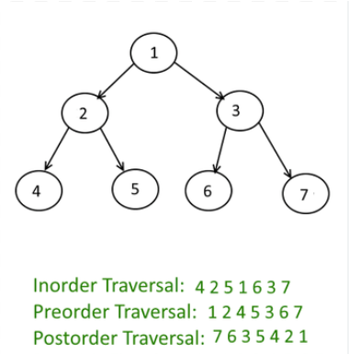
Algorithm for Implementation of BST & Binary tree traversal techniques:
- PREORDER TRAVERSAL:
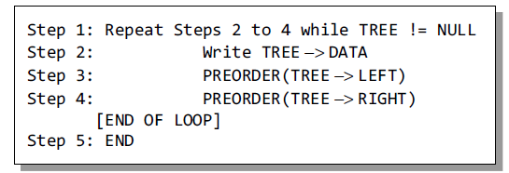

- INORDER TRAVERSAL:
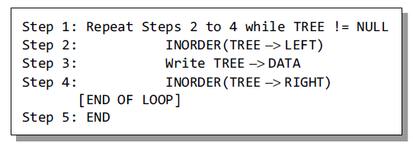

- POSTORDER TRAVERSAL:
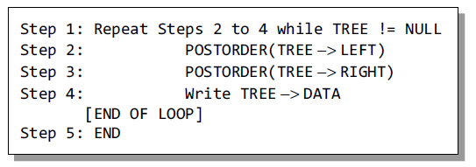

Implementation Details:
- Enlist all the Steps followed and various options explored.
Binary Tree Initialization:
The code initializes a binary tree by setting the tree pointer to NULL in the create_tree function.

User Menu:
The code presents a menu to the user with the following options:
Insert Element
Preorder Traversal
Inorder Traversal
Postorder Traversal
Count the total number of nodes
Count the total number of external nodes
Count the total number of internal nodes
Determine the height of the tree

Insert Element:
Users can insert a new element into the binary tree. The code prompts the user to enter the value of the new node and uses the insertElement function to insert it into the tree.

Preorder Traversal:
Users can choose to perform a preorder traversal of the binary tree. The preorderTraversal function is used to display the elements of the tree in preorder.

Inorder Traversal:
Users can choose to perform an inorder traversal of the binary tree. The inorderTraversal function is used to display the elements of the tree in inorder.

Postorder Traversal:
Users can choose to perform a postorder traversal of the binary tree. The postorderTraversal function is used to display the elements of the tree in postorder.

Count Total Number of Nodes:
Users can count the total number of nodes in the binary tree. The totalNodes function is used to calculate this value.

Count Total Number of External Nodes:
Users can count the total number of external (leaf) nodes in the binary tree. The totalExternalNodes function is used to calculate this value.

Count Total Number of Internal Nodes:
Users can count the total number of internal (non-leaf) nodes in the binary tree. The totalInternalNodes function is used to calculate this value.

Determine the Height of the Tree:
Users can determine the height (maximum depth) of the binary tree. The Height function is used to calculate the height of the tree.

User Input Handling:
The code reads user input for the menu options and, in some cases, for values to be inserted into the tree.

Looping Menu:
The code uses a do-while loop to allow the user to perform multiple operations without exiting the program.

Assumptions made for Input:
Option Selection: The code assumes that the user will enter a valid numeric option from the menu (1 through 8). If the user enters an invalid option (e.g., a character or a number outside this range), the code may not handle the input error gracefully.
Insert Element: When the user selects the "Insert Element" option (Option 1), the code assumes that the user will enter a valid integer for the new node's value. If the user enters a non-integer value or an out-of-range value, the code may not handle this error.
User Intent: The code assumes that the user will enter input that corresponds to the intended operation. For example, if the user selects the "Count the total number of nodes" option, the code expects the user to be interested in counting nodes and not entering unrelated data.

Built-In Functions Used: printff(), scanf(), malloc().

Program source code for Implementation of BST & Binary tree traversal techniques :
int pop() {
st.top = st.top - 1;
return st.array[st.top+1];
}

int main() {
char inputString[100], c;
int i, length;
initialize();
printf("Enter a string of paranthesis\n");
gets(inputString);
length = strlen(inputString);
/*
# for '{' : we push '{' in stack
# for '}' : we pop a character from stack. For every '}' there must be one '{' earlier.
This will ensure that
** There are equal number of '{' and '}' characters in string.
** For every '{' there is a '}' in input string later.

*/
for(i = 0; i < length; i++){
if(inputString[i] == '{')
push(inputString[i]);
else if(inputString[i] == '}'){
if (isEmpty()) {
printf("Stack is Empty...\n");
printf("InValid Paranthesis Expression\n");
return 0;
}
else {
pop();
}
}

Output Screenshots for Each Operation:

1) INSERTING
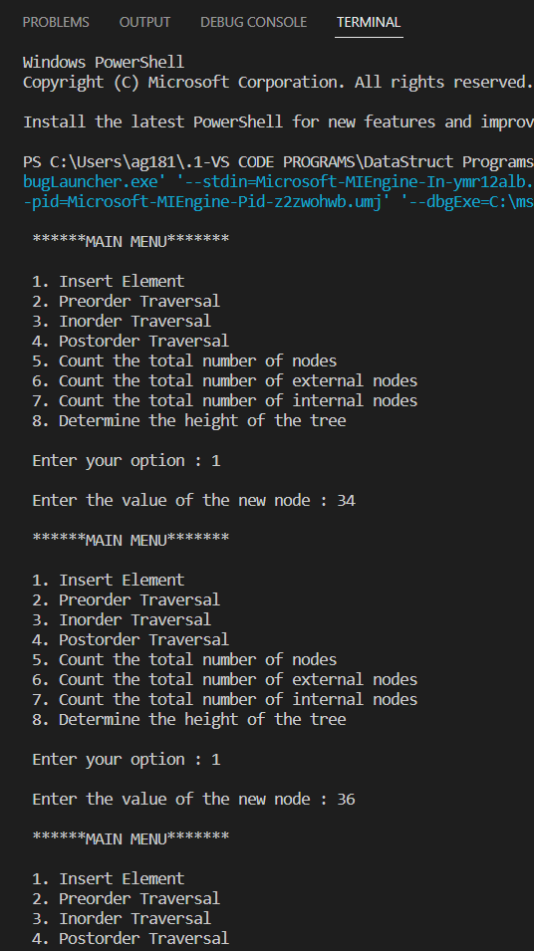

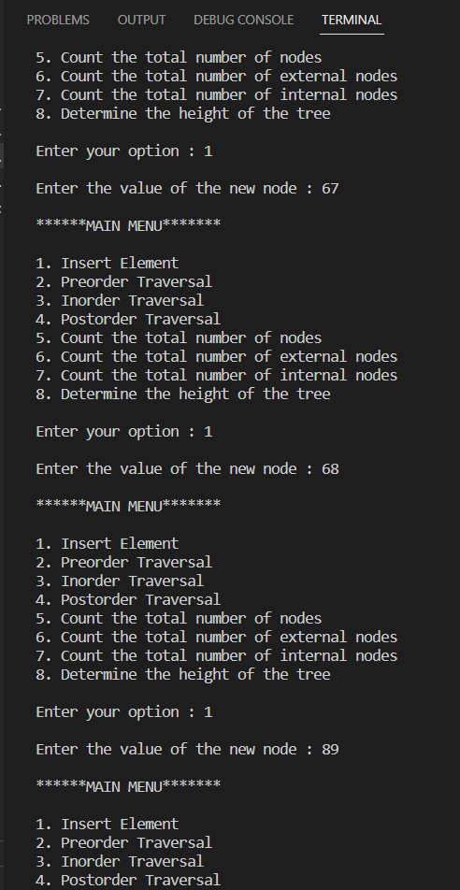

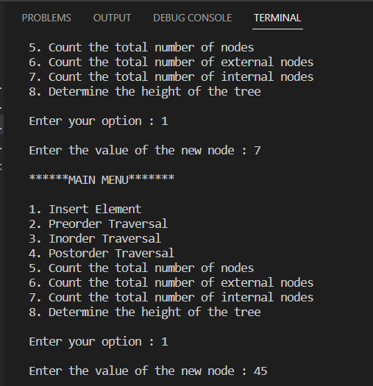

2)PREORDER TRAVERSAL
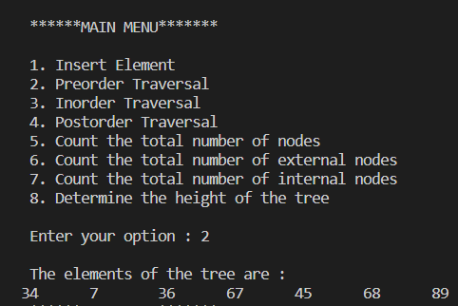

3)INORDER TRAVERSAL
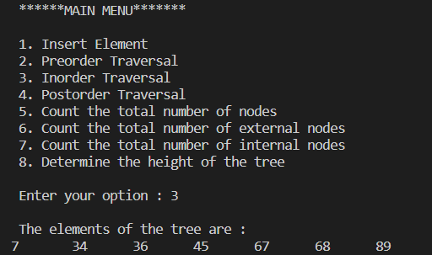

4)POSTORDER
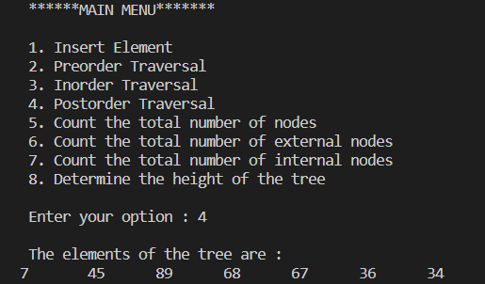

5)TOTAL NO. OF NODES:
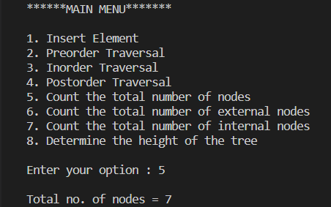

6)TOTAL NO. OF EXTERNAL NODES:
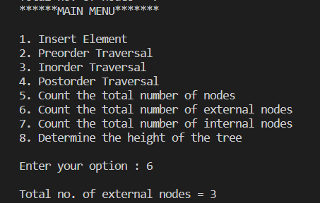

7)TOTAL NO. OF INTERNAL NODES:
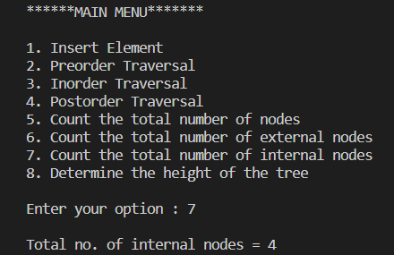

8)HEIGHT OF TREE:
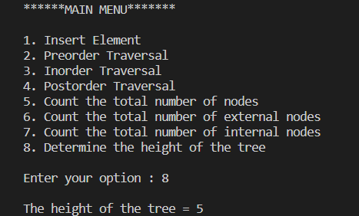

Explain the Importance of the approach followed by you

Dynamic Memory Allocation: The code dynamically allocates memory for each tree node using the malloc function. This dynamic memory allocation is essential because it allows the tree to grow and shrink as needed, unlike static arrays or fixed-size data structures.

Recursion: Recursive functions used for tree traversal and counting various properties make it an elegant and efficient way to handle tree structures, as it naturally mirrors the hierarchical nature of trees.

User Interaction: The code is designed to interact with the user through a menu-driven console interface. This interaction allows users to perform various operations on the binary tree, making the code practical and user-friendly.

Error Handling: The code does not have extensive error handling, but it assumes that the user will input valid options and values. In a real-world application, more robust error handling would be necessary.

Clear Output: The code provides clear and well-formatted output to the user, making it easy for users to understand the results of their chosen operations.

Conclusion:-
Implementation of BST and traversal techniques done successfully.

PostLab Questions:
- Illustrate 2 Applications of Trees.
  - File System
The files and folders that you see in your windows explorer are stored in the tree format. In the below image you can say that ‘My Computer’ is the root; Local Disk (C), Local Disk (D), and Local Disk (E) are basically the parent nodes and files inside them are leaf nodes. This allows faster traversal of the nodes while jumping from one node to another.

  - Webpage Layout
The layout of a webpage is designed in the tree structure. In the below diagram, the homepage or index page is our root node, main sections/ site index are their child nodes, which again are parents to multiple other child nodes (subsections).

- Compare and Contrast between B Tree and B+ Tree?
B tree | B+ tree
In the B tree, all the keys and records are stored in both internal as well as leaf nodes. | In the B+ tree, keys are the indexes stored in the internal nodes and records are stored in the leaf nodes.
In B tree, keys cannot be repeatedly stored, which means that there is no duplication of keys or records. | In the B+ tree, there can be redundancy in the occurrence of the keys. In this case, the records are stored in the leaf nodes, whereas the keys are stored in the internal nodes, so redundant keys can be present in the internal nodes.
In the B tree, leaf nodes are not linked to each other. | In B+ tree, the leaf nodes are linked to each other to provide the sequential access.
In B tree, searching is not very efficient because the records are either stored in leaf or internal nodes. | In B+ tree, searching is very efficient or quicker because all the records are stored in the leaf nodes.
Deletion of internal nodes is very slow and a time-consuming process as we need to consider the child of the deleted key also. | Deletion in B+ tree is very fast because all the records are stored in the leaf nodes so we do not have to consider the child of the node.
In B tree, sequential access is not possible. | In the B+ tree, all the leaf nodes are connected to each other through a pointer, so sequential access is possible.
In B tree, the greater number of splitting operations are performed due to which height increases compared to width. | B+ tree has more width as compared to height.
In Btree, each node has atleast two branches and each node contains some records, so we do not need to traverse till the leaf nodes to get the data. | In B+ tree, internal nodes contain only pointers and leaf nodes contain records. All the leaf nodes are at the same level, so we need to traverse till the leaf nodes to get the data.
The root node contains atleast 2 to m children where m is the order of the tree. | The root node contains atleast 2 to m children where m is the order of the tree.

